Enabling enhanced Mathematics teaching with interactive whiteboards

Aims of the project

- To develop a PD tool that focuses on using interactive whiteboard technology effectively to enhance mathematics teaching
- To inform and extend previous research into the effective use of interactive technologies in Mathematics classrooms

Two key questions focused the discussion and research during the project:

- What makes an effective resource that stimulates learning when using an interactive whiteboard?
- How can teachers develop their skills so they can create/use resources of this nature?

Dimensions of the study

The project involved seven teacher-researchers, most from the Keele area but including one teacher from an independent girls’ school in St. Albans and another from an 11-16 secondary school in Cambridge, who had a variety of experience in using interactive whiteboards and Mathematics software. Specialist input and direction was provided by Dave Miller, supported by the rest of the Keele University interactive whiteboard Mathematics team of Doug Averis and Derek Glover.

Summary of main findings

We found that activities that helped to stimulate learning using interactive whiteboards included those which:
- organised resources so that the teacher and students could move smoothly between phases of the lessons - so enabling a clear development of thinking between desk-based and board-based activities;
- used the potential of the board to interact with mathematical concepts in real time, such as using dynamic geometry, which enabled pupils to grasp the concept in more depth;
- enabled the teacher to enhance a deeper understanding of how and why Mathematics works, focusing on the process of learning rather than the final result;
- use familiar forms of manipulations, such as drag and drop or hide and reveal, that repeatedly used a subset of specific tools found in the interactive whiteboard software; and
- were underpinned by pedagogy, clearly identified in a choice of activities that developed pupils’ understanding without relying on exposition of facts.

Background and context

Many schools and local authorities have invested heavily in new technologies in the classroom and, in particular, interactive whiteboards. The pace of introduction has been swift and many teachers have found themselves working with this innovation on a day-to-day basis with little or no directed training, other than that provided by the manufacturers of the boards. Nonetheless many teachers were excited and enthusiastic about their introduction and their potential for enhancing learning.

However, the reality of what having an interactive whiteboard means soon becomes clear as it appears that users either require significant time to develop interactive resources or they have to find ready-made resources. As a consequence, the impact of interactive whiteboards in the classroom has been varied. In some cases, teachers have developed ways to enhance learning through interactive or live Mathematics. In other cases, teachers have benefited enormously from the organisational aspect of the board, using it to create lesson or topic resources that they can use repeatedly. More often, though, interactive whiteboards are underused with teachers doing little more than writing on it, showing PowerPoint presentations or using it as a screen that displays the internet. The impact that this has on pupils’ understanding of Mathematics is minimal, even with a possible increase in pupils’ motivation. We wished to explore why this was the case and identify what sort of development would be effective in maximising the potential of interactive whiteboards in Mathematics teaching.

Teaching processes and strategies

The group met termly at Keele University over a two-year period to discuss their thoughts, findings, available research and plan the content and context of the development tool.

Initial discussion about interactive whiteboard use
The project began by considering the positive experiences of the teacher-researchers when using their interactive whiteboards in lessons. Discussion was based on the questions:

- What sort of activities were most successful?
- What made them successful?
- How do we know that they impacted on learning?

This led the group to discuss the phases of learning for these tasks:

- What happened at the board and how did this stimulate learning?
- What happened at the desk and how did this stimulate learning?
- What happened in the head? How did what was happening at the board and at the desk affect each other and influence this (i.e. learning)?

Each member of the group shared resources and techniques that they use frequently in their lessons, giving us the opportunity to share the reasons why we considered the resources good and how we had used them in lessons. A number of similarities emerged and discussion began to focus on pedagogy rather than technical skills.

From this point the focus moved towards creating the development tool. The whole team identified which aspects of the interactive whiteboard software were the most important in creating these types of activities. This led to identifying the most successful strategies to support teachers in developing these skills and turning them into materials that could be used both on the CD development tool and in person through training events.

What sorts of activities did we use and how did students engage with them?
On sharing some of the resources we used frequently, such as those shown below, we identified what it was about them that stimulated learning.

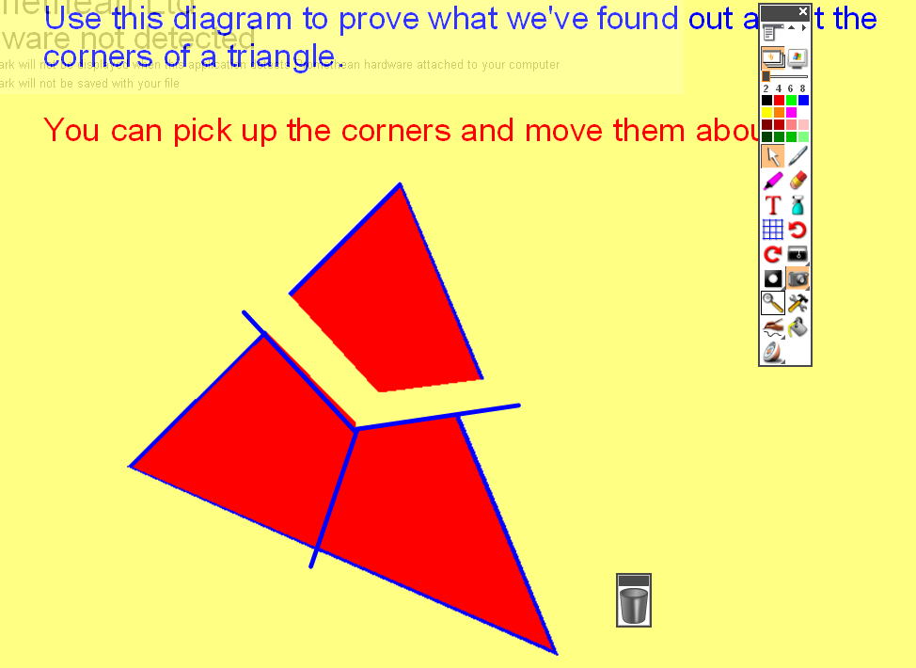
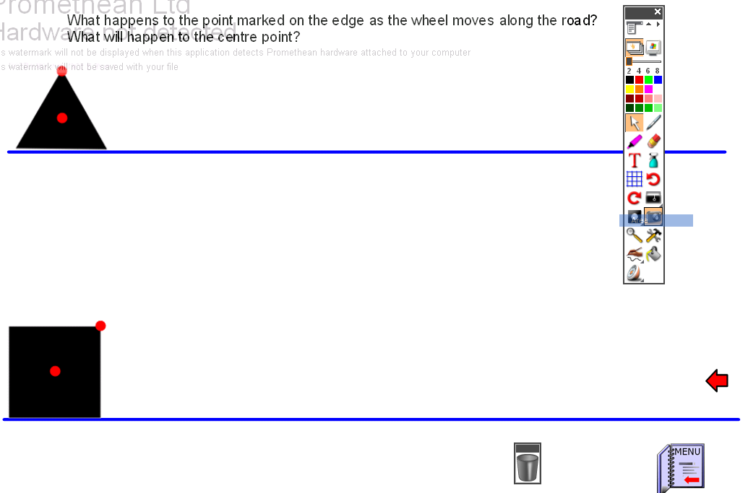
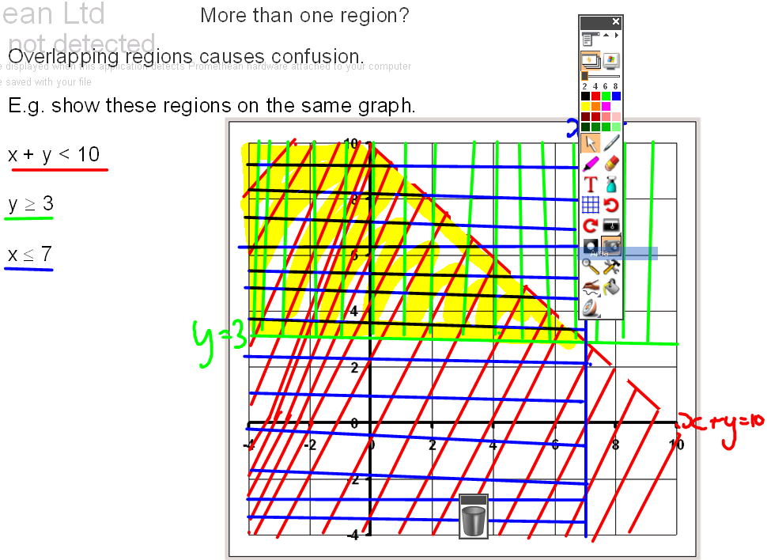
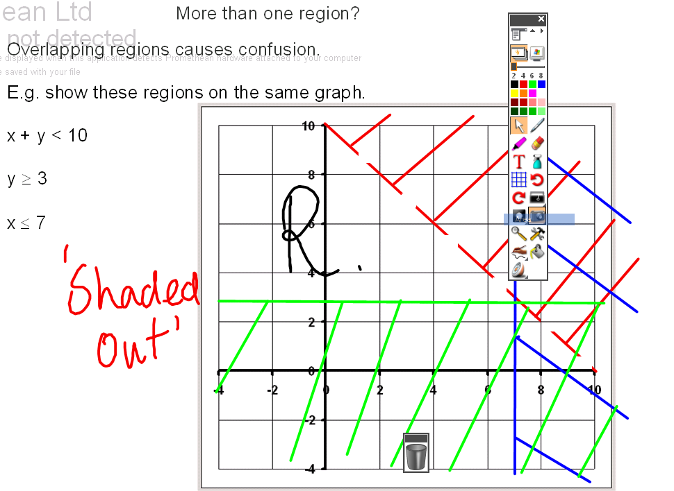

Most of the activities required the pupils to interact directly and to reason at the board. In many cases, the board work was repeatedly supplemented by similar activities that the pupils undertook in class on their desk: hence our ‘mantra’ – ‘at the board, on the desk, in the head’, noting that this does not mean that the board work comes first but rather that the work at the board should complement that on the desk and vice versa. At times these desk activities consisted of printed interactive whiteboard screens whereas, by contrast, at other times the board work consisted of virtual manipulative desk resources, such as cards to be sorted.

With each resource we considered, a similar pattern emerged which wasn’t as much about the actual activities on the resource but how they were used by the teacher and the pupils. Pupils worked independently or in groups on tasks and then used the interactive whiteboard to facilitate discussion and enable the teacher to advance their understanding. In some cases, they involved pupils interacting directly with the interactive whiteboard and the actual interaction itself provided the understanding, with the teacher working in a significant way to either lead or support or facilitate or enable or help create the learning.

The findings

Teachers’ use of interactive whiteboards
Our observations, shared discussion and analysis of teaching and learning materials led us to believe that teachers used interactive whiteboards more effectively for teaching and learning when:

- they had access to ready to use activities, with guidance on how they could be used effectively in class;
- they knew how to adapt or create activities for the whiteboard;
- they make use of familiar activities in order to identify the way in which using the interactive whiteboard enhances learning; and
- they are confident in using the most relevant tools from the interactive whiteboard software.

The development tool

We believed that it was important to focus the development tool we were constructing on:
- raising the issue of the pedagogy of interactive learning, using proven exemplar materials that may already be in use in schools;
- providing resources that modelled the key development phases in a clearly defined manner that teachers could use immediately in their own classrooms;
- providing training on the key tools on the leading manufacturers software, that would allow teachers to use the resources provided and to develop their own interactive resources at a suitable level of competence;
- being able to be used both for departmental and individual development to enable schools and teachers to use it for maximum impact; and
- reflecting current issues in teaching and learning Mathematics and supporting the change of focus to the Key Processes of Mathematics outlined in the new National Curriculum.

We concluded that we needed to create a simple ‘manual’ for teachers which would link with the resources provided. This would allow exploration of the impact of this style of teaching and learning without increasing workload, in particular, by learning to adapt resources. Furthermore, we decided that the focus should be on learning as much as it was on technical development so that the use of the interactive whiteboard would be accepted as a justifiable teaching style. By being user friendly, the tool would be accessible to all teachers regardless of their ICT capabilities and could become a valuable asset during PPA time. We also thought that it was important to encourage collaborative work within departments.

Research methods

Each of the teachers was observed and recorded or recorded themselves teaching using an interactive whiteboard. These videos were then analysed using these criteria:
- Teacher development through the following stages, identified by Miller et al in their report to Becta (2005)
  - Supported didactic: Some use of the interactive whiteboard but only as a visual support, little interactivity or pupil involvement
  - Interactive: Some use of the interactive whiteboard to stimulate pupils’ thinking through verbal, visual and aesthetic challenge
  - Enhanced interactive: This stage marks a progression in teachers’ thinking; teachers use the interactive whiteboard to prompt discussion, explain processes, and develop hypotheses or structures, with pupils working in groups/pairs; there is a wide variety of ‘home-grown’ and internet resources
- The use of gesture, based on the finding of Glover and Miller (2006)
- The use of questioning, using a tool based on Bloom’s Taxonomy

Further input was provided by the teachers in the group who were working with colleagues on developing interactive whiteboard use. In some cases, aspects of the research were shared with these colleagues and their thoughts used to inform further discussion. Feedback was also provided by Jennifer Piggott who evaluated the research on behalf of the NCETM.

Conclusion and ways forward

We all felt that our teaching benefited from this research and development project. One teacher stated that:

“It (the research) has made me think more in depth about every lesson I teach; how the board could be used more efficiently, how learning could be improved, what resources would bring the lesson alive, what activities could pupils get involved with at the board to reinforce mathematical ideas and discussion”.

To create this enthusiasm in teaching may require CPD, for which we aimed to provide a format in the development tool. This CPD should aim to:
- assist teachers in becoming more confident when managing day-to-day uses related to the technology and the associated software;
- provide a wealth of resources that could be used in everyday lessons;
- increase the effectiveness of PPA time in planning interactive lessons using the technology in such as way that benefits a greater number of teachers through collaborative development;
- identify needs for further training in pedagogy and technology; and
- increase the confidence of those teaching outside their subject specialism.

We hope that the development tool will live up to our expectations and offer a method by which departments can begin this CPD by providing insight into how the interactive whiteboard might be used in Mathematics to enhance pupils’ learning through a more interactive pedagogy. It is perhaps timely that it is available just as the new curriculum comes into place!

The development tool will be available from early September at www.iwbmathstraining.co.uk

Suggestions for further reading

Mathemapedia entry “Board, Desk, Head” on the National Centre for Excellence in the Teaching of Mathematics portal at: http://www.ncetm.org.uk/mathemapedia/BoardDeskHead.

Moss, G., Jewitt, C., Levačić, R., Armstrong, V., Cardini, A. and Castle, F. (2007). The Interactive Whiteboards, Pedagogy and Pupil Performance Evaluation: An Evaluation of the Schools Whiteboard Expansion (SWE) Project: London Challenge
Available at: http://www.dfes.gov.uk/research/data/uploadfiles/RR816.pdf

Enhancing mathematics teaching through new technology. The use of the interactive whiteboard: Advice for teachers of mathematics
Based on research funded by the Nuffield Foundation at Keele University, April 2002 - March 2004
Available from:
http://www.keele.ac.uk/depts/ed/iaw/docs/Advice%20for%20teachers%20of%20mathematics.pdf

MILLER, D. J. (2006). The magic box – enhancing interactivity, Mathematics Teaching, 197, pp. 28-31.
Also available at: http://www.atm.org.uk/mt/archive/mt197files/ATM-MT197-28-31.pdf

Materials from the research are available at http://www.iwbmaths.co.uk/

Authors’ contact details

Fran Wilson
Director of Mathematics with Computing/ AST
The Parkside Federation
Parkside
Cambridge
CB1 1EH
e-mail: fwilson@parksidefederation.org.uk
Dave Miller
Department of Education
Keele University
Keele
Staffordshire, ST5 5BG

e-mail: d.j.miller@educkeele.ac.uk

For further information about Enhancing Interaction in Mathematics Teaching and the training offered by Keele University visit http://www.keele.ac.uk/depts/ed/cpdactivities/eimt.htm

