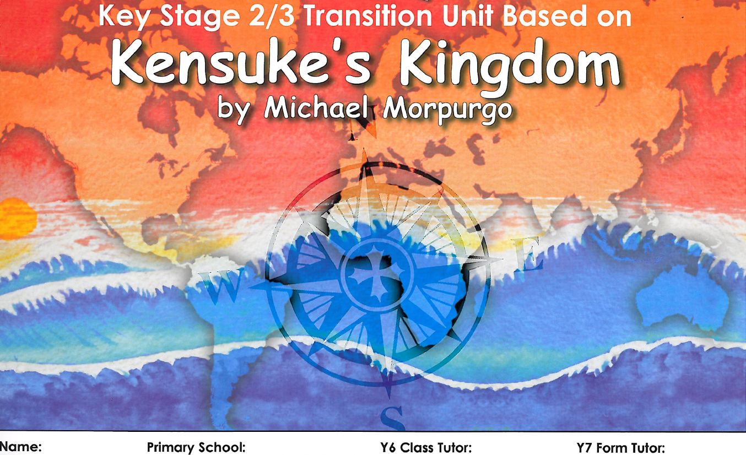
Based on Transition Unit book from Kenton School – many thanks to Val Wigham

