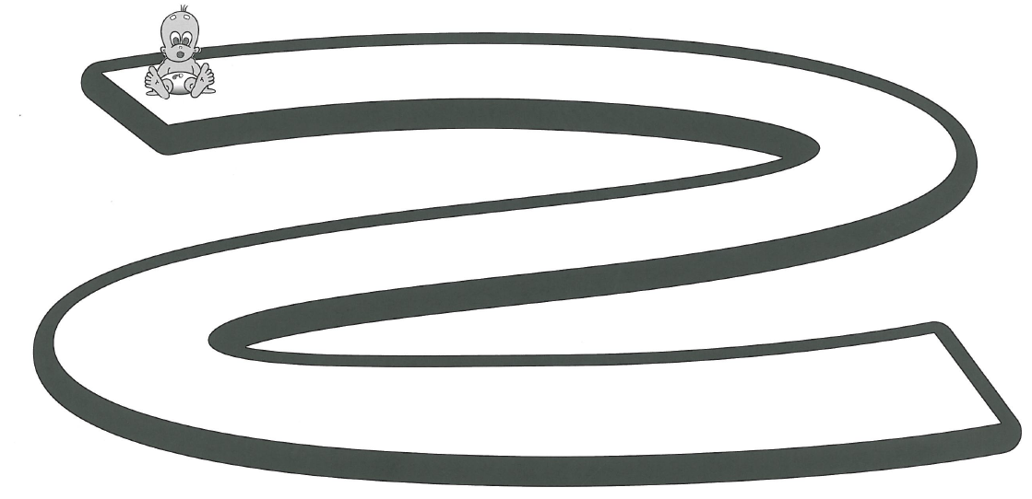
Plotting my journey 

Students preparing for secondary school
Before you complete the timeline, talk to your parents/carers about the important events in your life. What was your most enjoyable moment? Was there a time when you felt particularly proud of yourself?

Parents/carers
Spend some time listening to your child talking about the events in their life. Can you encourage them to explain their thoughts in full sentences? Can you help them use adventurous words to describe their experiences?

Just like Michael, you are about to embark on the next stage of your journey through life.
Complete the timeline of your life, from birth until now; include some of the important events in your life up to now. Try to look ahead and write in what your hopes and aspirations are for your life.
1

