
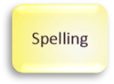
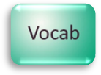
Languages

Students preparing for secondary school
First try using your hands to give the messages. Then practice saying your sentences to your parent or carer before you write them down,

Parents/Carers
Encourage your child to write in complete sentences. Work together to correct up to 3 spellings.

We often want to communicate with others. If we cannot speak at all or simply cannot speak the other person’s language, we have to find a different way of communicating with them. This could be by making particular noises, facial expressions, or gestures with parts of our body. In Chapter 5 when Michael met Kensuke for the first time, he realised that he had no idea what Kensuke was saying to him. Michael thought it sounded like Chinese or Japanese. However, he did know that Kensuke was agitated and angry with him.
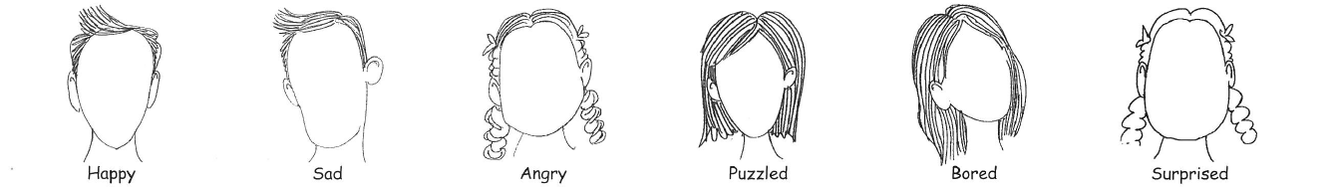
Can you draw some expressions on these faces to show how the people are feeling?
Write a sentence explaining how you would use your hand(s) to give these messages:
Pleased to meet you.
………………………………………………………………………………………………………………………
Come here, please.
………………………………………………………………………………………………………………………
Look at that!
………………………………………………………………………………………………………………………
Stop! ………………………………………………………………………………………………………………………

Now try this…
Make some strange faces by cutting out facial parts from pictures in magazines and sticking them together as a new face. Use an “Additional Page” at the back of the booklet.
Quiet please!
………………………………………………………………………………………………………………………
You shouldn’t do that!
………………………………………………………………………………………………………………………
Goodbye.
………………………………………………………………………………………………………………………

10

