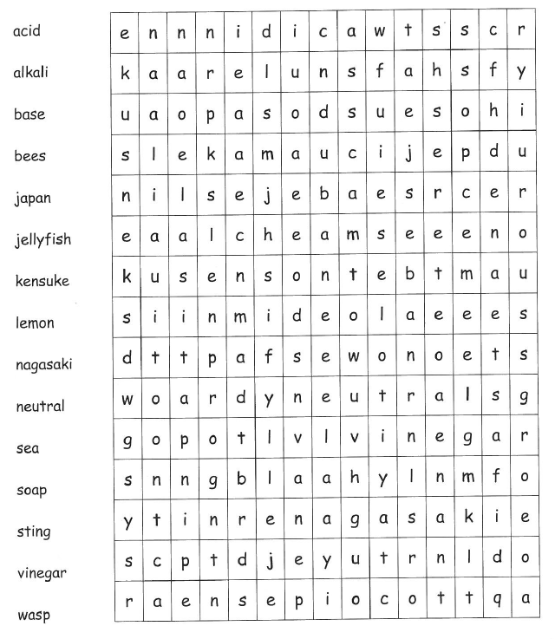
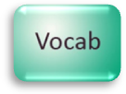
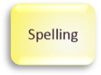
Acids and Alkalis

Students preparing for secondary school
Are any of the words in the wordsearch new to you? If so add them to your word wall. You will be learning more about acids and alkalis at your secondary school.

Parents/Carers
Support your child in reading the words in the wordsearch. Encourage them to sound out any new words and use a dictionary to find out what they mean. You could then take it in turns to read out a definition and match it to the correct word.

Find the following key words in the wordsearch:
Find the meanings of the following scientific keywords from the wordsearch and write them down.
acid:………………………………………………………………………………
alkali:……………………………………………………………………………
base:………………………………………………………………………………
neutral:…………………………………………………………………………
Now try this…
Find some examples of acids and alkalis.
Acids | Alkalis

11

