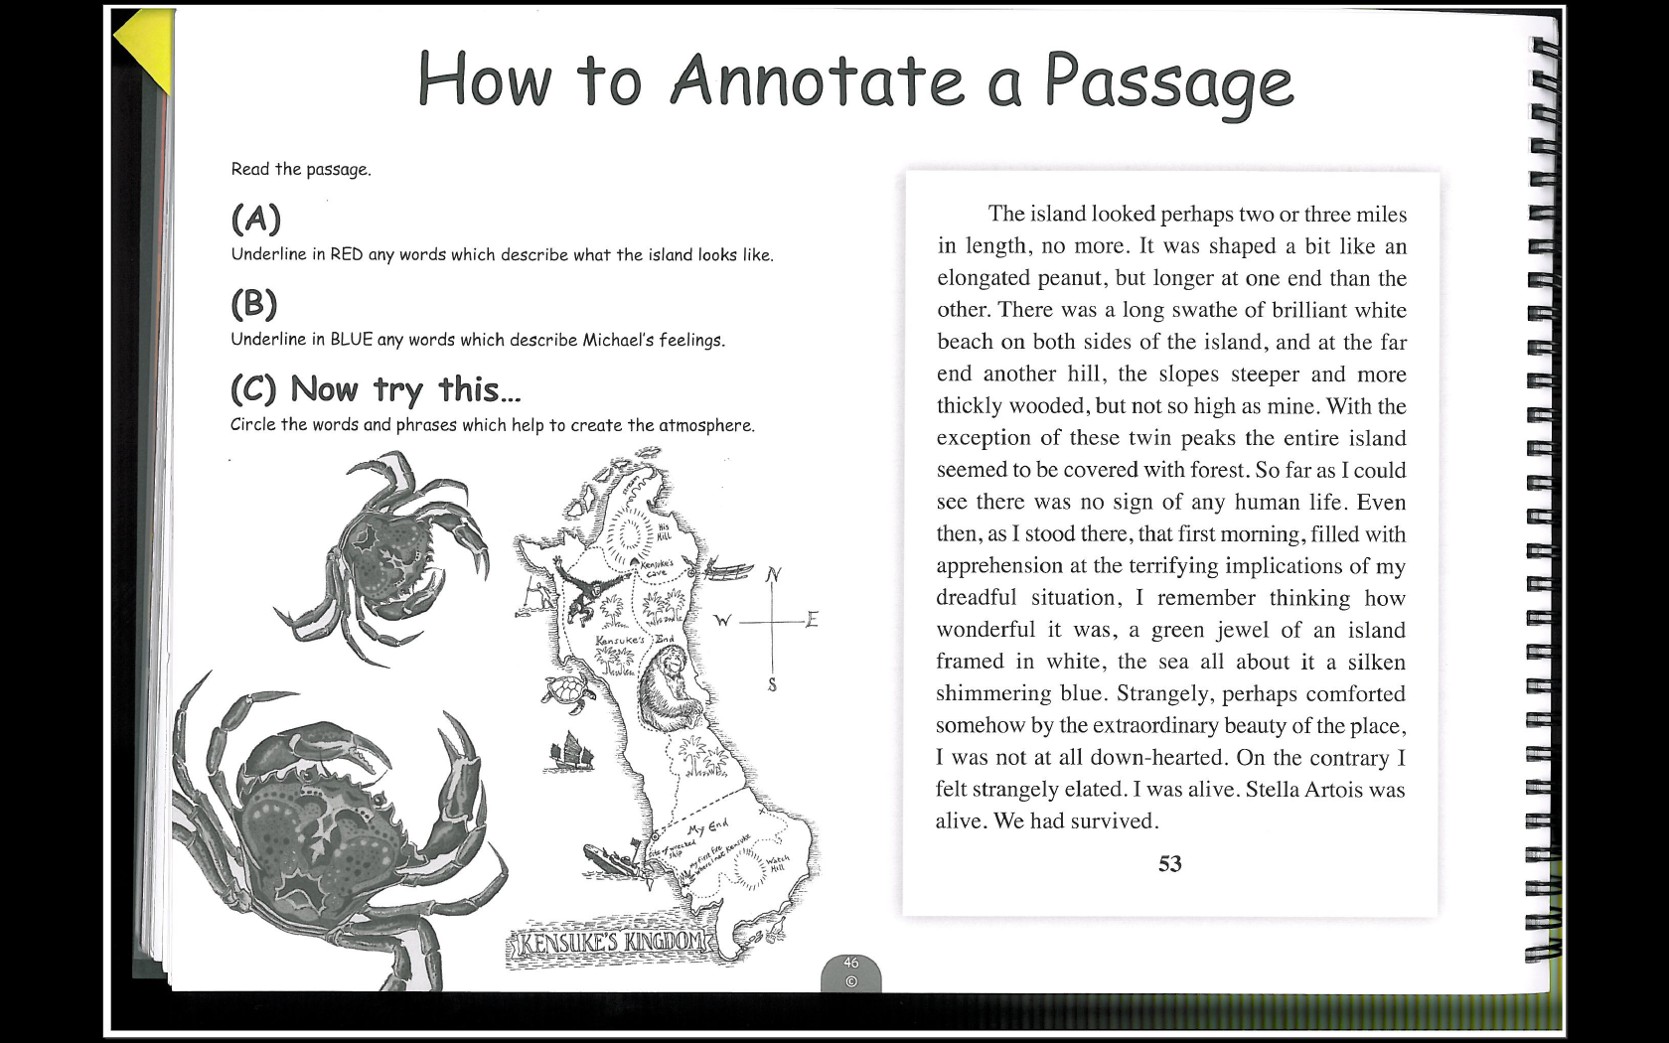
How to Annotate a Passage
Read the passage.
- Underline in RED any words which describe what the island looks like.
- Underline in BLUE any words which describe Michael’s feelings.
- Circle the words and phrases which help to create atmosphere.
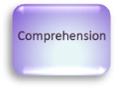
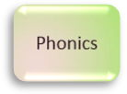
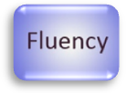

Students preparing for secondary school
Read the passage to your parent or carer. If you come to any new words, sound them out carefully. Can you practice reading the passage with lots of expression?

Parents/Carers
You could take it in turns to read the passage with expression. Can you use your voice to show how Michael is feeling?

12

