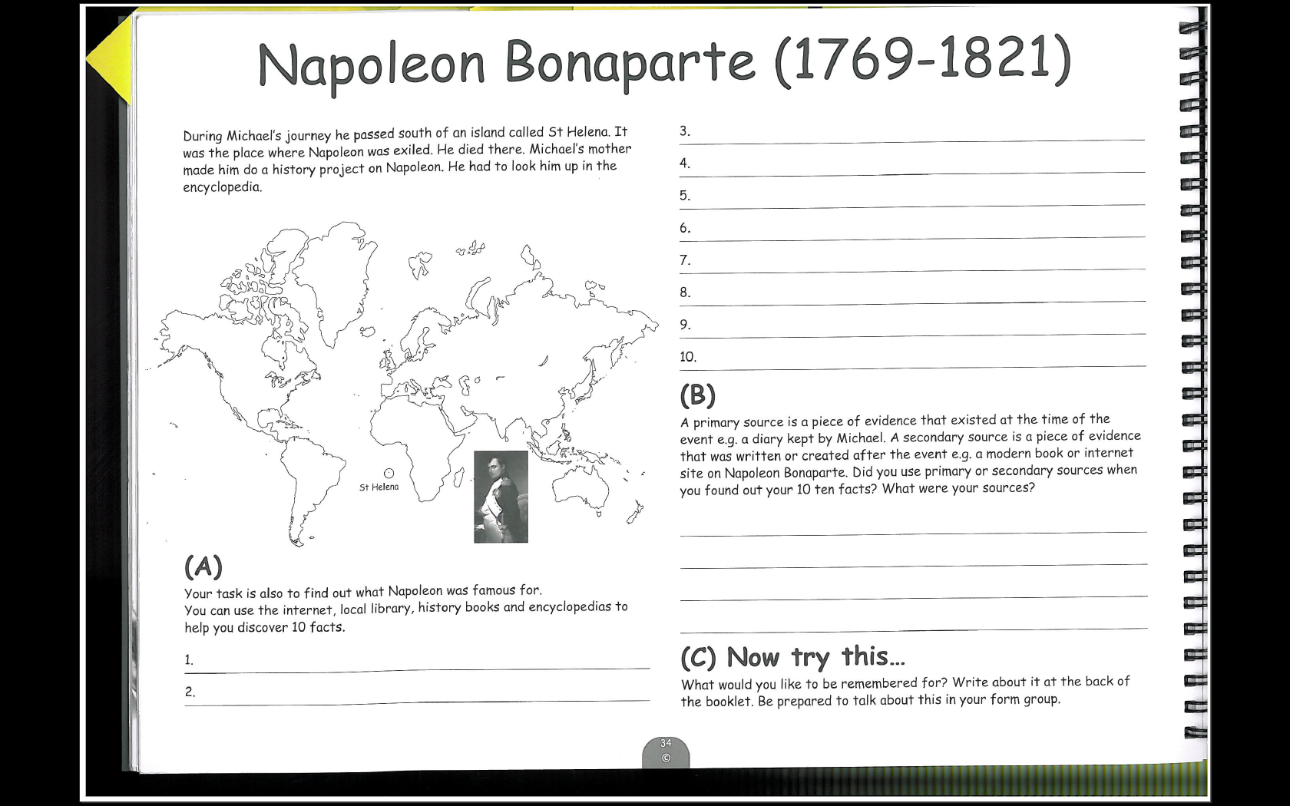
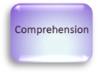
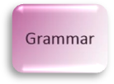
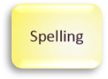
Napoleon Bonaparte (1769 – 1821)

Students preparing for secondary school
Make sure that your facts in section A are interesting and written in complete sentences. Don’t just copy them but write them in your own words! Have you used connectives?

Parents/Carers
Take it in turns to read the 10 facts and check that they are written in complete sentences. Work together to correct up to 3 spellings.

During Michael’s journey he passed south of an island called St Helena. It was the place where Napoleon was exiled. He died there. Michael’s mother made him do a history project on Napoleon. He had to look him up in the encyclopedia.
(A) Your task is also to find out what Napoleon was famous for. You can use the internet, local library, history books and encyclopedias to help you discover 10 facts.
1. ………………………………………………………………………………………………………………
2. ……………………………………………………………………………………………………………
3. ……………………………………………………………………………………………………………
4. ……………………………………………………………………………………………………………
5. ……………………………………………………………………………………………………………
6. ……………………………………………………………………………………………………………
7. ……………………………………………………………………………………………………………
8. ……………………………………………………………………………………………………………
9. ……………………………………………………………………………………………………………
10. ……………………………………………………………………………………………………………

(B) A primary source is a piece of evidence that existed at the time of the event, e.g. a diary kept by Michael. A secondary source is a piece of evidence that was written or created after the event e.g. a modern book or internet site on Napoleon Bonaparte. Did you use primary or secondary sources when you found out your 10 facts? What were your sources?
………………………………………………………………………………………………………………………………………………………………………………………………………………………………………………………………………………………………………………………………
……………………………………………………………………………………………………………………………………………………………………………………………………………………
(C) What would you like to be remembered for? Write about it at the back of the booklet. Be prepared to talk about this in your new school? schschscschschoolgroup.
13

