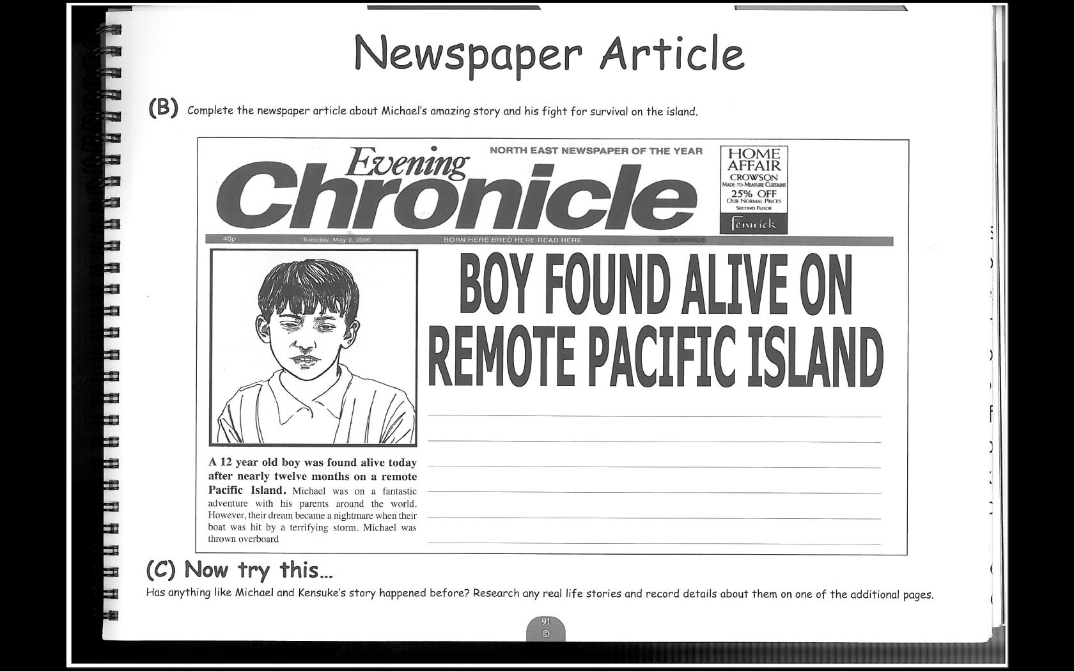



Now try this…
Has anything like Michael and Kensuke’s story happened before? Research any real life stories and record details about them on one of the additional pages.

Newspaper Article
Complete the newspaper article about Michael’s amazing story and his fight for survival on the island.

Students preparing for secondary school
Try and organise your article so that it clearly explains what happened and is interesting for the reader. Can you use any words from your word wall?

Parents/Carers
Take it in turns to read through the article. Can you child find ways to make the article even more interesting to read. Work together to correct up to 3 spellings.

14

