

The Next Stage of Your Journey

Students preparing for secondary school
Well done for all your hard work this holiday! This will really help you when you start your new school.

Parents/Carers
Use this opportunity to celebrate how hard your child has worked over the holidays and that this will have helped them to prepare for their new school.

Just like Michael, you are about to embark on the next stage of your journey through life. Michael has mixed feelings at first to be leaving his home and friends but he soon realises what a fantastic opportunity lies ahead. You too will have very mixed emotions about your first day at your new school, and will be feeling very nervous.
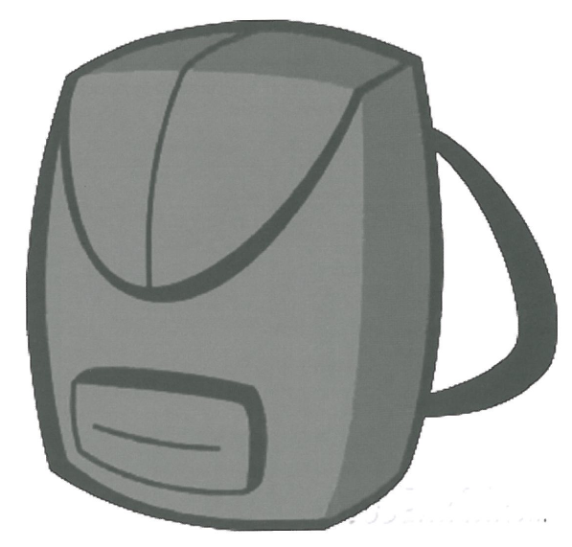
Describe what you would pack in your school bag to help you get through the first week.
Equipment I will need…
…………………………………………………………………………………………………………………………………………………………………………………………………………………………………………………………………………………………………………………………………………………………………………………………………………
The skills I need to take are…
…………………………………………………………………………………………………………………………………………………………………………………………………………………………………………………………………………………………………………………………………………………………………………………………………………
Now try this…
Write an account of your ideal 1st day at your new school
…………………………………………………………………………………………………………………………………………………………………………………………………………………………………………………………………………………………………………………………………………………………………………………………………………………………………………………………………………………………………………………………………………………………………………………………………………………………………………………………………………………………………………………………………………………………………………………………………………………………………………………………………………………………………………………………………………………………………………………………………………………………………………………………………………………………………………………………………………………………………………………………………………………
15

