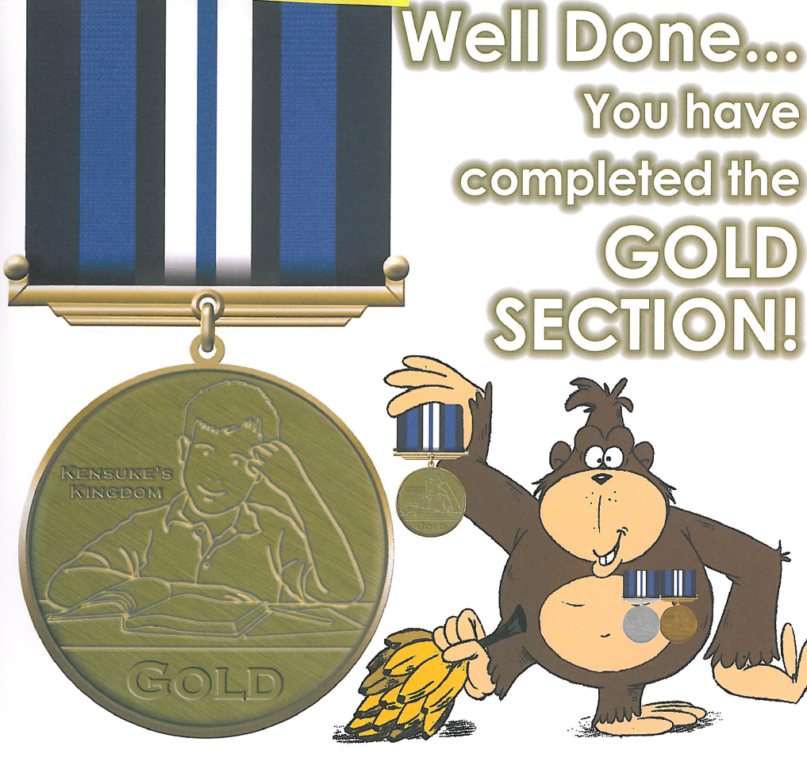
Name………………………………… Tutor Group…………………………….
I have successfully completed the Gold section of Kensuke’s Kingdom and received 100 graduation points.
Signed (Teacher) …………………………… Date…………………………
100
Points!
Please complete this form, cut along the dotted line and give it to your teacher
16

