


Sailing Around the World

Students preparing for secondary school

Before you complete the page practice your argument with your parent or carer. Tell them what you would write to complete each sentence. Are they convinced by your conclusion about whether the trip should go ahead?
- Can you use the structure to create an argument for doing a particular activity this holiday?

Parents/Carers
- You will want to talk through ideas with your child before they start writing. Encourage them to present their ideas in full sentences and use adventurous vocabulary. Work together to check up to 3 spellings in the piece.
- Look out for opportunities to use the structure to make up arguments for and against certain activities during the holiday (e.g. watching a particular programme/film or visiting the park).

Use this sheet to help you construct a really good argument for and against the trip.
I am not sure that sailing around the world with my family would be a good thing because
……………………………………………………………………………………………
……………………………………………………………………………………………
On the other hand
……………………………………………………………………………………………
……………………………………………………………………………………………
However
……………………………………………………………………………………………
……………………………………………………………………………………………
One good thing about it would be
……………………………………………………………………………………………
……………………………………………………………………………………………

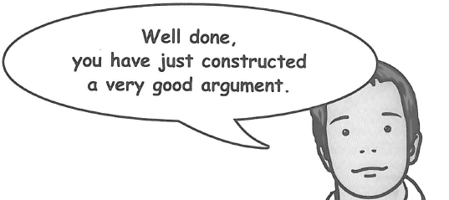
Nevertheless
……………………………………………………………………………………………
……………………………………………………………………………………………
Another point of view is
……………………………………………………………………………………………
……………………………………………………………………………………………
In conclusion
……………………………………………………………………………………………
……………………………………………………………………………………………

When you have written this, check your spelling and punctuation very carefully.

3

