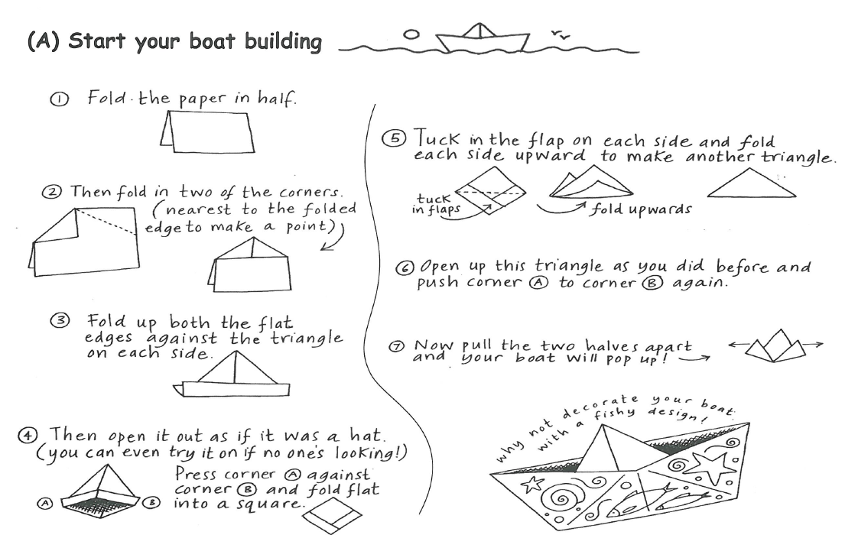
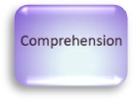
Float Some Boats

Students preparing for secondary school

Whilst you are making the boat, read out each instruction to your parent. How accurately can you follow the instructions?

Parents/Carers
Encourage your child to read the instruction aloud and follow each step as accurately as possible. If they don’t get it right first time encourage them to try again.

4

