


Design a sail for your paper boat.

Students preparing for secondary school
- Before you draft your design, use the internet or library to find out a bit more about Japanese art and Koi carp. Read some of the information with your parents. Can you identify any new vocabulary to add to the word wall (on another page in this book)?

Parents/Carers
- Support your child in using the internet or library to find out more about Japanese art and Koi carp. Choose some short passages and take it in turns to read them aloud. If your child is hesitant or slow the first time, you should encourage them to have another go.

Use patterns inspired by Japanese art and Koi carp.

Do a draft of your design here, then transfer it onto your sail.

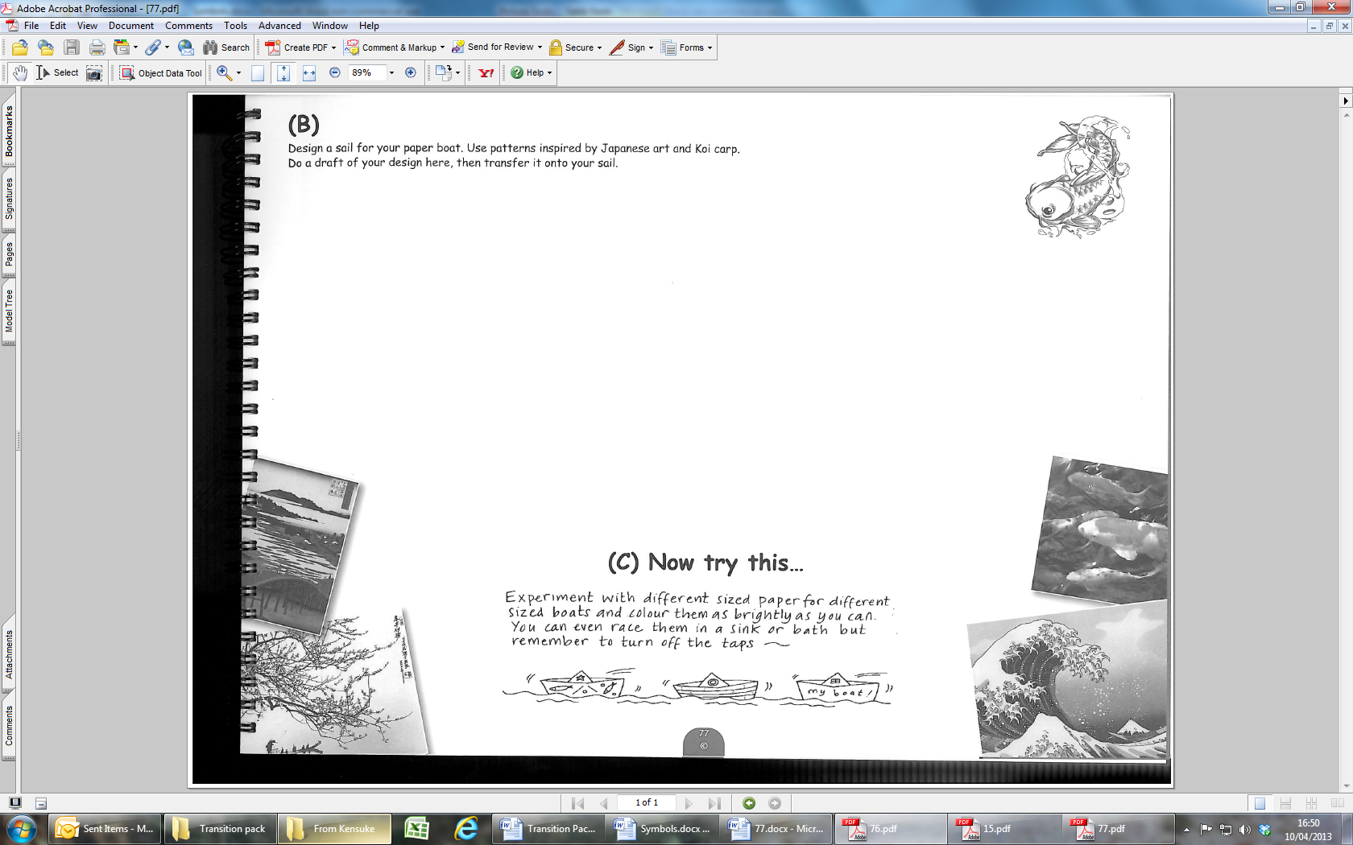

Now try this…
5

