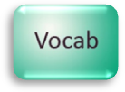
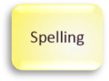
New Vocabulary – Word Wall

Students preparing for secondary school
See how many different types of text you can use to you can fill the word wall over the holiday e.g. a story, a newspaper article, an information text etc.

Parents/Carers
Support your child in finding and reading a range of different types of text over the holidays and using these to find words to go in the word wall. See if you can help your child to learn to spell the words.

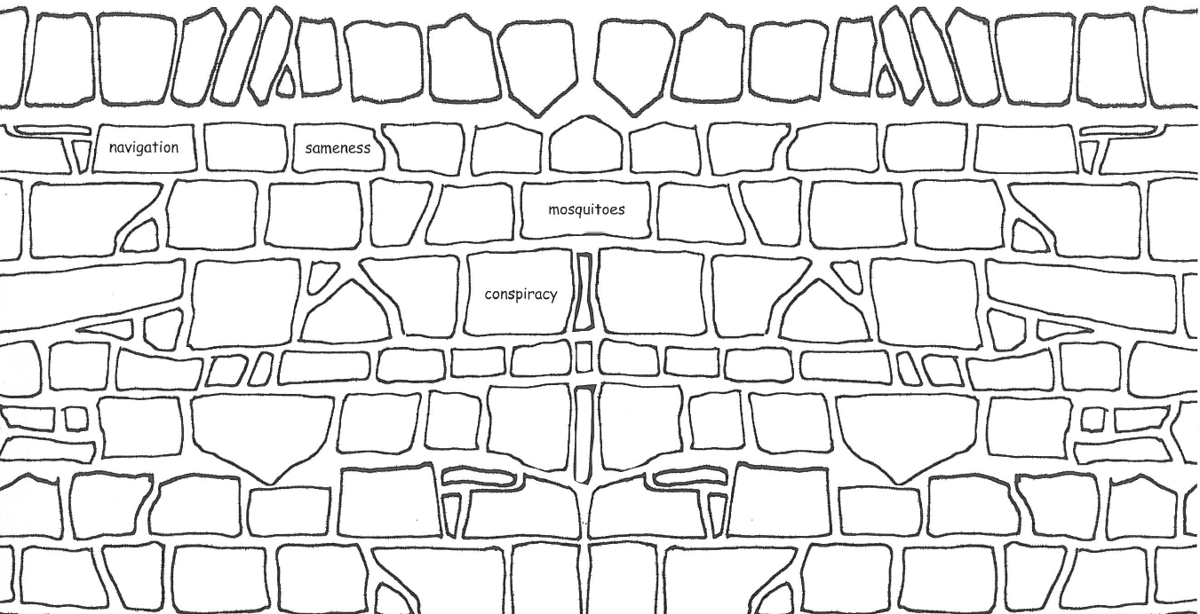
This wall has bricks which need filling in. Every time you learn a new word from re-reading or listening to Kensuke’s Kingdom (or from other reading you do over the holidays), write it on one of the bricks on the wall. See if you can fill every brick in with a new word.
6

