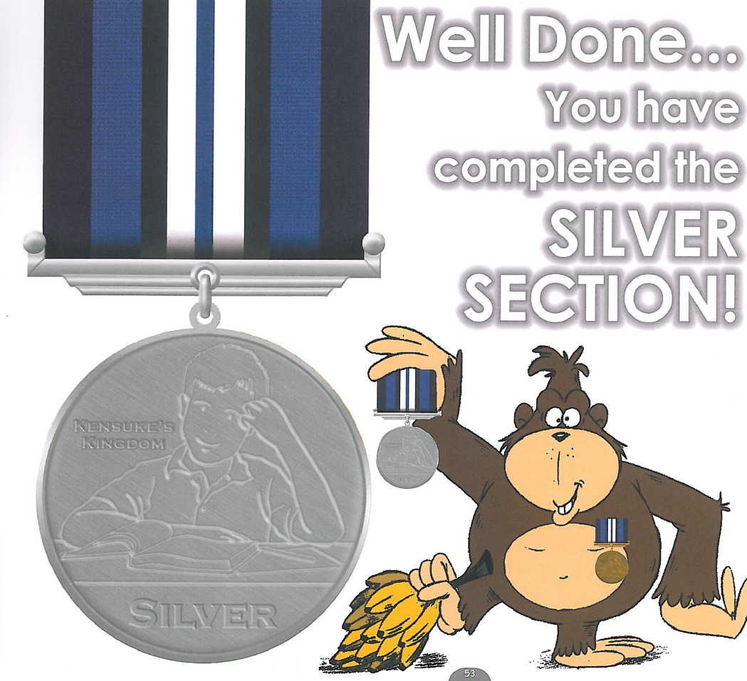
Name………………………………… Tutor Group…………………………….
I have successfully completed the Silver section of Kensuke’s Kingdom and received 50 graduation points.
Signed (Teacher) …………………………….. Date ….…………………
50
Points!
Please complete this form, cut along the dotted line and give it to your teacher
7

