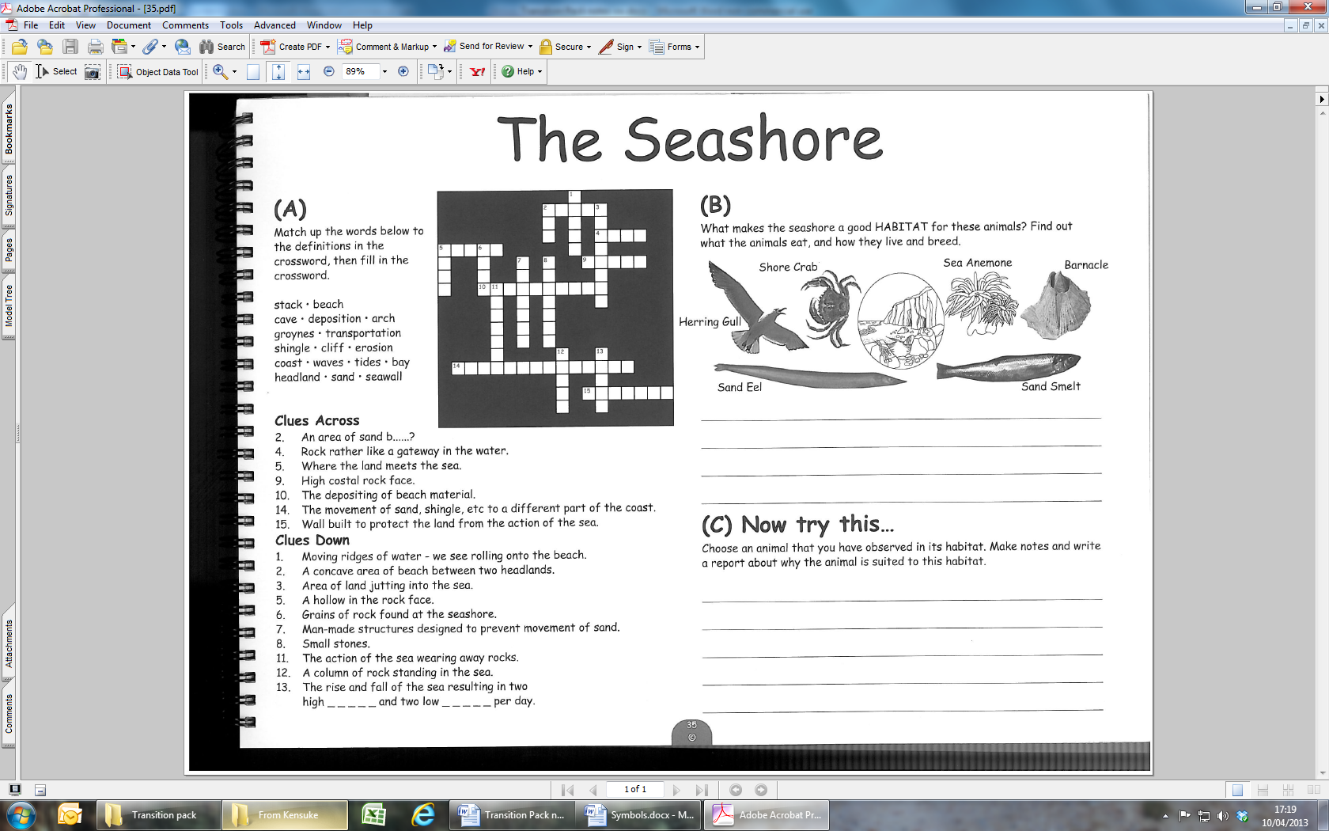
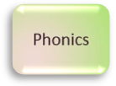
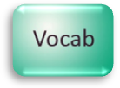

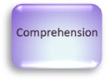
The Seashore

Students preparing for secondary school
Are any of the words in section A new to you? If so add them to your word wall. When you are using the internet or books to research the animals in section B see if you can identify any new words.

Parents/Carers
Support your child in reading the words in section A. Encourage them to sound out any new words and use a dictionary to find out what they mean. You could then take it in turns to read out a definition and match it to the correct word.

(B) What makes the seashore a good HABITAT for these animals? Find out what the animals eat, and how they live and breed.

………………………………………………………………………………………………………………………………………………………………………………………………………………………………………………………………………………………………………………………………………………………………………………………………………………………
………………………………………………………………………………………………………

(C) Now try this…
Choose an animal that you have observed in its habitat. Make notes and write a report about why the animal is suited to its habitat… …………………………………………………………………………………………………………………………………………………………………………………………………………
……………………………………………………………………………………………………………………………………………………………………………………………………………

8

