


Design a Board Game

Students preparing for secondary school
Think of your own ideas for the game. To help you make sure that your instructions are clear read them to your parent/carer, friends and family and ask them to follow them exactly. Do they do what you would expect?

Parents/Carers
If your child’s instructions are a little unclear at first encourage them to improve them until they are clear and easy to follow. Check with them that they are all written in complete sentences. Work together to correct up to 3 spellings.

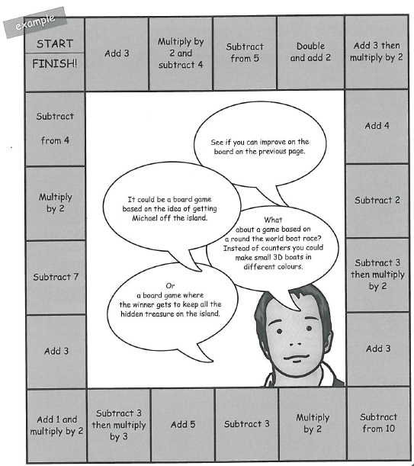
Design your own board game based on Kensuke’s Kingdom.
Tips!
- Make sure that your rules are clear and easy to understand.
- Try them out on another person.
- Is there an instruction on every space on your board game?
- Do they all make sense?
- Play your game a few times to see if it works. Ask someone else to play it – does it still work?

Use symbols in your instructions. For instance ‘multiply by 2 and take off 4’ can be written as ‘dice score x 2 – 4’. Add 3 can be written as ‘dice score + 3’
Now try this…
- Think about the shape of your puzzle board – can you design it to link to a theme from Kensuke’s Kingdom? Ideas: an orang-utan, a ship, a fire.
- Use more complex mathematical operations in your board game.
- Use ‘d’ for dice. Write instructions for each square as algebraic expressions, e.g. double the number on the dice, then add one, and then square the answer would be (2d+1)²

9

