Do children have similar models of understanding for seeing, hearing and smelling?

Aims of the project

Many curricula include information about seeing, hearing and smelling, and an appreciation of these senses is related to an understanding of the behaviour of light, sound and gases. The National Curriculum for England requires sound to be taught in Year 5 and seeing to be taught in Year 6. It states that pupils should be taught that vibrations from sound sources require a medium through which to travel to the ear and that we see things only when light from them enters the eye. While there is no specific requirement to teach about the sense of smell, the QCA KS2 science document uses this to teach the children about gases.

The questions that the study asked were:
- what kinds of models do the children bring to their learning and how can this knowledge inform teaching strategies?; and
- do children have similar models of understanding for seeing hearing and smelling?

Dimensions of the study

The study was a snapshot of Year 3-Year 6 understanding of how the children understood hearing, seeing and smelling. The study was based on the responses of 355 primary school pupils.

Summary of main findings

The drawings and annotations of 7 to 11-year-old English children suggested that, overall, they seemed to use five models for the senses of hearing, smelling and seeing:
- the receptor; nose, eyes, mouth, etc.;
- outreaching; an active seeking-out of stimuli;
- sensing-as-instant; a belief that stimuli and events interact simultaneously;
- clashing-arrows; a meeting of outreaching and stimuli somewhere outside the body; and
- arrows-both-ways; a dynamic interaction between stimuli and receptor.

In addition it was evident that:
- children’s models were context driven, in that they often had totally different models for each of their senses;
- very few children who used the receptor model for one sense used it for all three; and
- the outreaching and sensing as instant models were tenacious.

Background and content
This study used an analysis of children’s drawings, lines, arrows and annotations to glean their ideas about the senses. The use of arrows and lines is very common in KS2 assessment of science and can be seen used in SAT tests particularly to assess children’s understanding of sight.

These annotations were used to sample the ideas of Year 3-6 boys and girls (7-11 year olds) from one school in a fairly prosperous area of an English West Midlands industrial town during the autumn term of 2003 and all in the same week. Of 335 children, 85 were in Year 3, 84 in Year 4, 88 in Year 5 and 78 in Year 6. The children came from a number of different cultural backgrounds including Indian, European, West Indian and Pakistani. While the students in this school are taught about hearing and smelling in Year 5, and seeing in Year 6, this research was conducted at the beginning of the academic year before such teaching had occurred that year.

Teaching processes and strategies
Rather than changing the teaching practices and then assessing the impact on learning, this study tried to assess informal learning and use this to inform new teaching practices. The impacts of new teaching methods are the topic of another study.

The findings
Overall, five common models were found, across all year levels, for seeing, hearing and smelling. These were:
- the receptor (scientifically accepted);
- outreaching;
- sensing-as-instant;
- clashing arrows; and
- arrows-pointing-both-ways.

The following are illustrations of how children understand seeing, hearing and smelling according to these models.

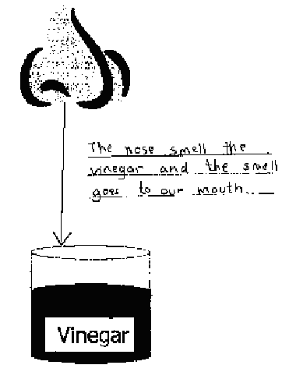
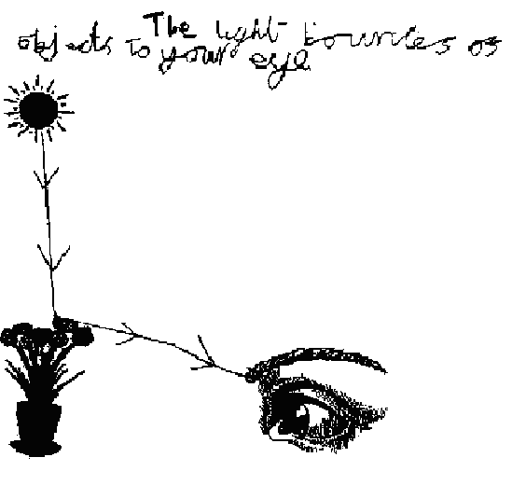
Figure 1. Seeing: Receptor model of an 11-year-old boy. “The light bounces of [sic] objects to your eye.”
Figure 2. Smelling: Outreaching model of an 8-year-old girl. “The nose smell [sic] the vinegar and the smell goes to our mouth.”

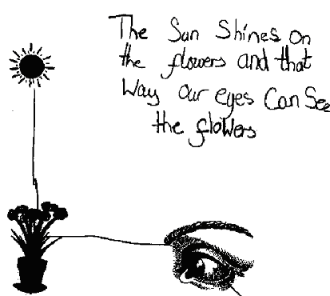
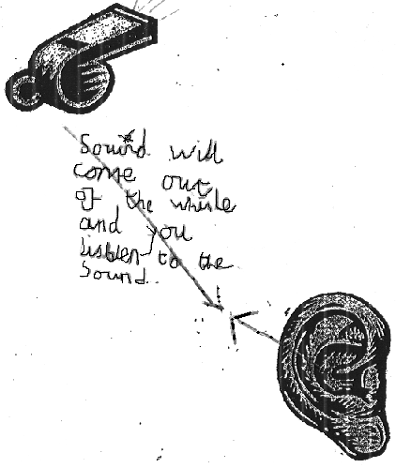
Figure3. Seeing: Sensing-as-instant model of an 8-year-old girl. “The Sun shines on the flowers and that way our eyes can see the flowers.”
Figure4. Hearing: clashing arrows model of an 10-year-old boy. “Sound will come out of the whisle [sic] and you listen to the sound.”

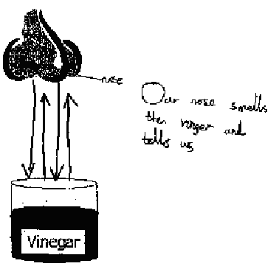

Figure5. Smelling: Arrows-pointing-both-ways model of an 8-year-old boy. “Our nose smells the vinegar and tells us.”

The outreaching and sensing-as-instant models were the most prevalent. Least common were the receptor and clashing arrows models.

The outreaching and sensing-as-instant models appeared tenacious; neither appeared to be readily susceptible to the conventional teaching practices being adopted. I predicted that the children using the receptive model for one sense would be likely to use it for the other senses as well but this was not borne out by the results. These showed very few students using the receptor model for all three senses.

The fact that children were unaware that, for example, sensing is not an instant activity and that it involves stimuli travelling, may well reflect a limiting factor in their learning – the use of language.

Children appeared to glean meaning both from what adults have told them and from their understanding of the language used. This raised questions for me; for example, does describing materials as “see through” rather than “transparent” exacerbate problems? Does language describe models or does language determine models?

Research methods
In this study drawings were used to sample the ideas of Year 3-6 children (7-11 year olds), such as the examples in the findings section. Each child was given three sheets depicting a clip-art scenario for each of seeing, hearing and smelling, together with pencils and erasers. They were asked to “use lines, arrows and words to show how you see, hear and smell” and worked on their own without any other intervention. Following an initial examination of results, a relatively small number of 30 children were interviewed in an attempt to confirm the analysis of the drawings. A sample of children from each of the models was interviewed.

Implications for practice
Regardless of the model that children have for sensing the environment, there must be some attempt to challenge what they perceive to be true even when they have the accepted scientific model. Asking the children to gather supporting evidence enables their scientific models to become more robust. Ideally, all children should end up with a model of passive sensing organs, with stimuli traveling to them from a source. What follows are suggestions for how the various models of sensing can be challenged.

Smelling
Use a long-stemmed pipette to place vinegar inside a balloon (not inflated) and seal the balloon with a knot. Ask the children to smell the balloon to see if they can smell the vinegar and they can’t. This means that there is an obstacle between them and the smell that cannot be overcome by an outreaching of their sense of smell. Then, add vinegar to balloons, inflate the balloons and seal them with a knot. This time, when the children smell a balloon, they will be surprised to find that they can smell the vinegar, even with a supposed barrier in the way. How could the smelling involve an outreaching if there is an obstruction in the way? With a little effort, the children might suggest that:
• when blown up, the balloon must have very small holes in its wall that allow the smell to
get out. Air must have particles larger than the holes, because it is trapped inside the
balloon;
• the liquid must be evaporating and turning into a gas (fumes, smells);
• the gas particles must be very small indeed to get through the holes in the wall of the
balloon;
• the gas particles must be smaller than some air particles;
• some of the air can escape through the holes because this is why balloons go down after
birthday parties;
• air must be made up of different gases, some having large particles and some with small
particles;
• either the liquid particles are stuck together, or larger than the holes, because they did not
flow out;
• gas flows from its source to the nose. The nose does not go out to get the smell;
• smelling cannot be instant, because something had to pass through the holes in the balloon
and travel to the nose; or
• the sense of smell involves receptors that sense their surroundings but do not outreach.

Hearing
Have children observe the behaviour of a slinky. Tell them that sound travels through the air as a compression wave and that this is similar to the way the coils in the slinky move. When they realise that sound travels from a source, they then begin to realise that they do not need to outreach with their ears and this will be particularly so if they are constructing this understanding on the basis of their knowledge about smelling. I use Newton’s Cradle to teach sound movement through a solid, although a physicist tells me that it is a dangerous analogy because of the curved motion it produces in the end-ball. However, this does not seem to be a problem for the children and they readily accept the idea of sound traveling through a solid without the movement of the solid to any great degree.

Seeing
Understanding vision is the most problematic for children but after developing an understanding of
the other two senses, this provides an opportunity to further build on the concept of things
travelling to receptive sense-organs. Start in a darkened room and ask students if they can see
anything. The response will be “no, because there is no light.” Light is needed for vision to occur
but many students will retain the outreaching and sensing-as-instant models. Blindfold the children
and switch on the light. With the light now on, ask why they can’t see. The answer might come that
because their eyes are covered, they cannot see out! Then ask how many can see light seeping into their eyes past the blindfold and many will likely raise their hand. How can you see this with the blindfold in the way if the blindfold is a barrier that you can’t outreach through? Ask them to
remove their blindfolds but to keep their eyes closed. Ask if they can tell whether the light is on or
off and they will be able to do so easily. So, with eyes closed, they couldn’t be outreaching and
light must be seeping into their eyes from outside. Then give them coloured acetate spectacles and
ask them to open their eyes. Why do their eyes now see everything in one colour only? What has
happened to their eyes to make this happen? The only explanation the children will likely consider
sensible is that the acetate changes the light seeping into their eyes. However, experience suggests that these vision challenges are not as successful as the smelling and hearing ones and you will still be left with a substantial number of children who are unsure. Once alternative models are learnt, their decay seems to be very slow. It seems the earlier an alternative model is learnt, the more stable it will be in a child’s everyday working knowledge and the fact that many children are quite happy to have different models for different senses is evidence of this; if this is so, the earlier the intervention the better.

Conclusion
The formal learning about the senses to which the students in this study had been exposed, although limited, does nevertheless not appear to have produced the outcomes one might desire, suggesting that these students are carrying alternative conceptions that could cause them difficulty later in their education. This appears to be evidence for the need to revise the approach presently being used so that the wide experiences and challenges students encounter build on stronger foundations. Only then will students appreciate the role of science as a tool for unravelling the mysteries of nature rather than being a collection of incomprehensible facts; but how might such a revision be accomplished? There appears to be a need for further investigation of how the ideas of, particularly primary children in this age range, are initiated and evolve, and how alternative conceptions might effectively be challenged.

Suggestions for further reading
Champagne, A., Gunstone, R., & Klopfer, L. (1983). Naïve knowledge and science learning. Research in Science and Technological Education. 1, 173-183.

Eaton, A., Anderson, C., & Smith, E. (1983). When students don’t know when they don’t know. Science and Children, 20, 7-9.

Hayes, K., Symington, D., & Martin, M. (1994). Drawing during science activity in primary school. International Journal of Science Education, 16, 265-277.

Kuiper, J. (1994). Student ideas of science concepts: Alternative frameworks? International Journal of Science Education, 16, 279-292.

Osborne, J., Black, P., Smith, M., & Meadows, J. (1990) SPACE Report: Light. Liverpool: Liverpool University Press.

Russell, K., Longden, K., & McGigan, L. (1991). SPACE Report: Materials. Liverpool: Liverpool University Press.

Author details
Anthony Cuthbert
e-mail: tony.cuthbert@talk21.com

