

Cakes and conversation
www.curee.co.uk

Please contact Rebecca.raybould@curee.co.uk
or Kirsty.bond@curee.co.uk to book or
for further information.

.

Curriculum design for effective learning experiences - Taster session

Event date/time:
4.30 -5.30pm Wednesday 19th October

Price
£20

Location
CUREE offices near the station

Find details at www.curee.co.uk

.

Whatever your view on subject or thematic approaches to the curriculum and whatever the results of the review of the curriculum the evidence about what works is clear. Effective curricular share 7 key characteristics. CUREE analysed the evidence from a large number of reviews of international research and carried out in-depth research of successful schools in England to identify these characteristics and gain information about how they worked in practice.

Join us for our ‘Cakes and Conversation’ taster session to explore some of the evidence and related resources about what works in effective curriculum design.

This taster session will:
- introduce you to some nuggets of evidence about the 7 characteristics of effective curriculum design;
- provide an opportunity to discuss the evidence with colleagues from other schools; and
- introduce you to CUREE resources which signpost the evidence schools need about effective curriculum design.
.

The taster is designed to be a purposeful, engaging and refreshing opportunity for:
- senior and middle leaders with an interest in developing the curriculum in their school; and
- primary and secondary practitioners with an interest in using evidence to improve practice.

This session will be facilitated by Rebecca Raybould. Rebecca has headship and advisory experience. Her role in CUREE focuses on helping practitioners uses research and evidence to improve outcomes for their learners.

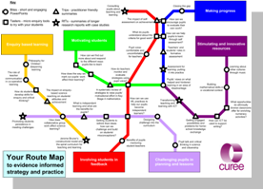

All CUREE programmes are rooted in the evidence about what really works in classrooms and how teachers learn.

A bespoke CUREE routemap provides teacher-friendly resources for school priorities. It puts the evidence you need at your fingertips.
“An extremely valuable and user friendly tool”

