
Centre for the Use of Research
and Evidence in Education

A case study of Peer Coaching to promote effective interventions
in pupil behaviour

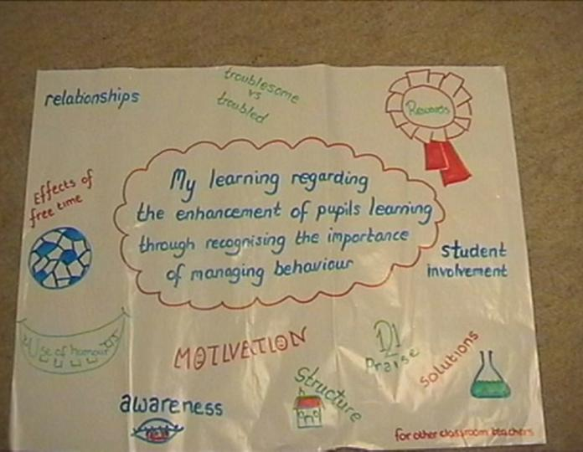

CPD that has helped teachers to improve pupil behaviour

Aim
This CPD programme aims to provide teachers with an extensive tool box of strategies for tackling poor behaviour.

Context
This is an open national programme. Participants come from schools with very successful and active behaviour strategies as well as from schools in special measures, from urban and from rural communities. Participants have come mainly from key stages 2&3. Steps are taken to ensure that concerns of male and female teachers in relation to behaviour are addressed. Participants have ranged from highly experienced and confident senior teachers seeking to refine their skills to newly qualified teachers. The programme is sponsored by a national teacher union.

Nature of the Project
The programme is offered to pairs of teachers committed to developing an effective peer coaching relationship as a means of informing and supporting their development. Teachers work initially with external tutors to identify a range of strategies and to start to interpret and develop their use in the teachers’ school contexts. Teachers provide peer coaching based on structured observation and feedback to each other over approximately 14 weeks. They review their learning, consolidate skills and plan how to share learning with colleagues at a closing residential. The opening residential addressed issues such as:
- factors which influence pupils behaviour in the classrooms – producing a classroom management template to address the behaviour needs and patterns of all class members;
- using problem solving approaches and observation to understand and explain pupil behaviour and to identify what can and can’t be done;
- techniques for building positive relationships and positive, self reinforcing cycles;
- understanding and managing patterns and variations in behaviour in group settings;
- matching strategies to needs and context, structuring observation, coaching and feedback;
- detailed planning and goal setting; and

Critical elements proved to be:
- illustrating how new strategies or understandings work in classrooms through detailed examples (often humorously portrayed);
- working on a sustained basis an agreed ‘contract’ in pairs;
- a session focused on responding positively to confrontation outside the classroom;
- the development and use of practical tools for use in classrooms;
- developing public, structured, supportive yet challenging peer coaching contracts focussed on improving behaviour in classrooms; and
- establishing a challenging but non threatening, non judgmental environment

Implementation
An initial 24 hour residential provided:
- an opportunity to work with external tutors in behaviour management and peer coaching;
- a safe environment for identifying fears and problems;
- mix of practical strategies and insights supported by underpinning theory to enable teachers to grasp what new approaches from tutors and each other really involve and to understand how they might be related to their own context;
- training in observation and peer coaching; time to agree goals, success indicators, support structures and resource needs; and
- a wide range of activities in pairs, small groups and plenary sessions to enable teachers to test out strategies and hypotheses.

Peer Coaching over 14 weeks involved
- classroom observation/video recordings;
- discussions with colleagues in schools;
- regular meetings for pairs of teachers to:
- give and receive feedback;
- review actions;
- reflect on problems and causes;
- plan next steps.

Review and consolidation involved
A further 24 hour residential, planned at the end of the first residential, to tackle unmet needs reviewed in the light of teachers’ evaluation of their achievements and continuing needs at the end of the peer coaching phase.

Resource needs and implications
The residential setting was highly valued by teachers as a means of enabling them to build trust in their pairs, recognise, make explicit their concerns and make effective plans.

Explicit and planned times for peer coaching
Planned release time for teachers to observe pupils and their peer coach together was especially important to primary teachers but was valued by all. Peer coaching sessions usually took place outside the school day but where it was possible for time to be released for a peer coaching session immediately after observation this was valued immensely. Some observation sessions were quite short but nonetheless valuable in providing teacher with a fresh insight into behaviour patterns, problems and strategies.

Effective and extensive course materials
Many of which could be used as classroom teaching and/or management tools.

Use of video camera and video recordings
Video clips of behaviour problems and strategies were used within the residential programme. Video cameras were available within the residential for experimenting with feedback techniques. Access to video camera to enable peer coaching to review teaching, learning and behaviour episodes together and to enable observation to take place without the particular teacher leaving the classroom.

Pairs of Teachers
Releasing two teachers together from one school for residential is proving increasingly difficult. One pair of teachers from two separate schools within a EAZ gained enormously from the experience, and both felt able to share these gains with colleagues in their own schools (so two schools benefited) because of the time allocated to peer coaching and the structure and expectations that were embodied in their mutual contract. The gains have far outweighed the cost and many pairs have continued to support each others’ learning after the conclusion of the programme.

A contract
The contract is a formal statement signed by the pairs of teachers. A copy is kept by NUT, the programme sponsors so that its contents are public. Contents of the contract are revisited and progress evaluated in the second residential.

Outcomes
(This section needs further and more concrete detail follow up call, visits or letters planned as parts of the programme haven’t yet taken place but further, more concrete detail could easily be obtained by phone)
Almost every teacher participant reported a good deal of personal success in meeting detailed goals set out in their contracts for peer coaching.

One pair of teachers in 2001 did not make the second seminar because of a second ofsted inspection visit in their school (but asked, nonetheless for further materials)

Almost all pairs of participants set continuing and challenging learning goals for their partnership after the completion of the programme and identified a set of concrete activities and resources for achieving them. Over half of these related to sharing their learning with colleagues in the department or schools. Four teachers reported disappointment about how far they had been able to take their contracts in the context of whole school policies.

71% reported that the seminars has been very effective in increasing their knowledge and understanding about making effective interventions in pupil behaviour and 29% reported that it had been quite successful (other choices not really, not at all, don’t known).

A strong (and for many participants new) sense that CPD is an activity that teachers provide for and with each other.

Reports of significant increases in confidence and willingness to try new strategies were universal.

Other information
The programme is sponsored by NUT. It is free to NUT members and available at cost to non members.

Problems
Securing teacher release for the residential was reported as being difficult. Teacher release for observation and peer coaching was reported as much harder still because the period coincided with the ‘flu’ and increasing teacher strategies.

The more teachers put into their contracts and to peer coaching observation the more they gained from it. Obstacles to this included school clusters where there were major behaviour problems or closure plans.

Transferability
The peer coaching model is certainly transferable to other contexts. Establishing as supportive a context as that afforded by the union sponsorship would require some care in other settings. The NUT uses the peer coaching model as a framwork for a range of CPD programmes including enhancing writing, ICT for NOF graduates, schools self evaluation and assessment for learning.

