DfES National CPD Strategy: Mentoring and Coaching Consultation

DfES LEA CPD Seminar Report

September - October 2004

______________________________________________________________________________

As part of the current DfES National CPD Strategy, CUREE is leading a project to develop clarity about the nature of effective mentoring and coaching and to support and promote coherent and effective practice in this area.

Learning Objectives
During the optional discussion at the recent DfES LEA CPD events, we looked at the definitions of mentoring and coaching emerging from practice and from consultation with national agencies such as GTC, TTA and NCSL. The objective of the first part of the session was to test the definitions framework against LEA practice and experience of mentoring and coaching.
- “Specialist expertise + coaching skills = specialist coaching, which is focused and targeted”
- “Mentoring can be about management or the working context while coaching is to do with teaching and learning or specific leadership skills”
- “Coaching implies ownership”
- “Peer coaching is to do with lesson/classroom activity whereas specialist coaching is to do with skills”
- “Mentoring sounds like someone doing something to someone else (top-down model) – potentially a problematic power relationship”
- “Coaching is finite and time-specific whereas mentoring implies a longer term relationship”
- “Specialist coaches should be recognised as having advanced skills and as being the expert”
- “Coaching is specific to skills, is targeted and has agreed outcomes. Mentoring is more fluid and is about agreeing ground rules and relationships”

The second part of the discussion focused on how mentoring and coaching are used in different LEAs.

This report highlights the key issues that arose during discussion at the 6 regional seminars.

Definitions
There were mixed views about the framework of definitions. Some people felt that mentoring and coaching were not sufficiently distinct from each other as to warrant separate consideration. Others wanted more and clearer definitions and believed it to be important to have a common language for both government agencies and for practitioners and providers to help build coherence.

Participants also:
- supported the proposal for developing a common language with which to describe and understand detailed aspects of current practice;
- felt it would be useful to distinguish between mentoring and coaching based on the process, the relationships between the people involved or the context.

Other commonly made points emerging from the meetings included:

The diagrammatic representation of the activities involved in mentoring and coaching proved to be a useful consultation tool. A number of people have already adapted it to use within their own fields.

Activity Circles Diagram

Some of the key points raised about the activities featured in the diagram included:
There was much discussion around the
- uncertainty about the ‘specialist’ label and preference for the term “skilled”;
- concern about the terms ‘assessing & appraising’ featuring in the mentoring circle as the mentor-mentee relationship is about trust, confidentiality and risk-taking; therefore assessment and appraisal was often seen as an inappropriate role for a mentor;
- the need to include ‘developing emotional competence’ as part of the activities;
- concerns about ‘counselling’ appearing as part of the mentor role as it requires proper, formal qualifications. It was thought instead that the mentor should be able to recognise when it’s time to involve counselling expertise;
- the importance of emphasising that observation for coaching is learning focused, separate from appraisal and often involves quite small but specific sections of lessons;
- recognition that looking for & giving support is a key activity for head teacher mentoring.

The Relationship between Mentoring & Coaching
There was much discussion around the nature of mentoring and coaching: in particular as to whether they were mutually exclusive or whether people could move in and out of roles at different times and in different places.

In general, coaching was considered to be a subset of mentoring with peer coaching (a subset of coaching) thought to be a good entry point for building coaching skills. There was also recognition that there are different types of mentoring roles and a need for a progressive framework for mentoring skills which recognised the ambiguities around the assessment and monitoring involved in current models of ITE and some forms of leadership mentoring.
Skills
Most people agreed that being a mentor or coach brings its own professional development benefits. Mentors need to be more reflective and to fine-tune thinking about what constitutes good practice. Gaining the skill to articulate practice can lead to improvements in their own classroom practice as well as in their mentoring practice.

Some frequently made comments about skills required by mentors and coaches included:
- “A mentor helps and enables you to reflect”
- “The skills needed are questioning, listening, emotional and interpersonal skills”
- “It is important to have a mentor who is not making judgements lots of the time about a mentee’s performance”
- “A coach doesn’t suggest that someone isn’t good enough but instead provides the opportunity to bounce/reflect ideas off someone to enable them to be so”
- “The coach doesn’t necessarily have to be better but they do need to be able to hold up a mirror to the other’s performance”

There was a continuing and lively debate between those emphasising the importance of specialist knowledge versus generic coaching skills and vice versa. At one seminar the project team explained, and recurred a positive response to the suggestion that generic coaching skills might be sufficient all the time that the professional learner has good self awareness and a detailed diagnosis of their development needs. Without such insight coaching will depend upon specialist knowledge from the coach or another colleague.

A key question for everyone was whether mentoring and coaching skills can be both specified and taught. Delegates also wondered whether it would be possible to develop some sort of diagnostic tool to identify best candidates to fulfil the role of mentor or coach.
However, while supporting the general concept of identifying and clarifying roles and characteristics, there were concerns about having national standards and an over prescriptive approach. Delegates were assured that this project is about developing a clear evidence based framework to facilitate the development of effective practice not about imposing standards.

Outcomes

There was general agreement that more emphasis should be placed on the potential outcomes of mentoring and coaching, and that was a need to demonstrate their benefits both for individuals and for groups or schools.

In particular, clearly understood outcomes were thought to be likely to be helpful for evaluative purposes and to provide rigour to the processes. Some also suggested that the activity needs to be documented, clearly and simply.
People Involved
It was suggested that the project needs to give thought to the question of selecting mentors and coaches with the specific needs of the coachee or mentee in mind. This also raised the issue of who should undertake the role of selecting the mentor or coach.

It was also thought to be important to recognise the limits of mentoring and coaching.

The interrelationships with other roles such as line manager, colleague, friend, team member etc. were also highlighted as a key issue.

The role of the organisation was seen to be in promoting a learning culture in which ‘good’ mentoring and coaching can be sustained.

Examples of Good Practice
We would like to hear about good practice in mentoring and coaching, about what makes it good and whether there are any schools or groups of schools who would be interested to contribute their own learning materials e.g. examples of learning agreements, protocols for defining roles, observation frameworks and other recording tools.

We look forward to hearing from you.

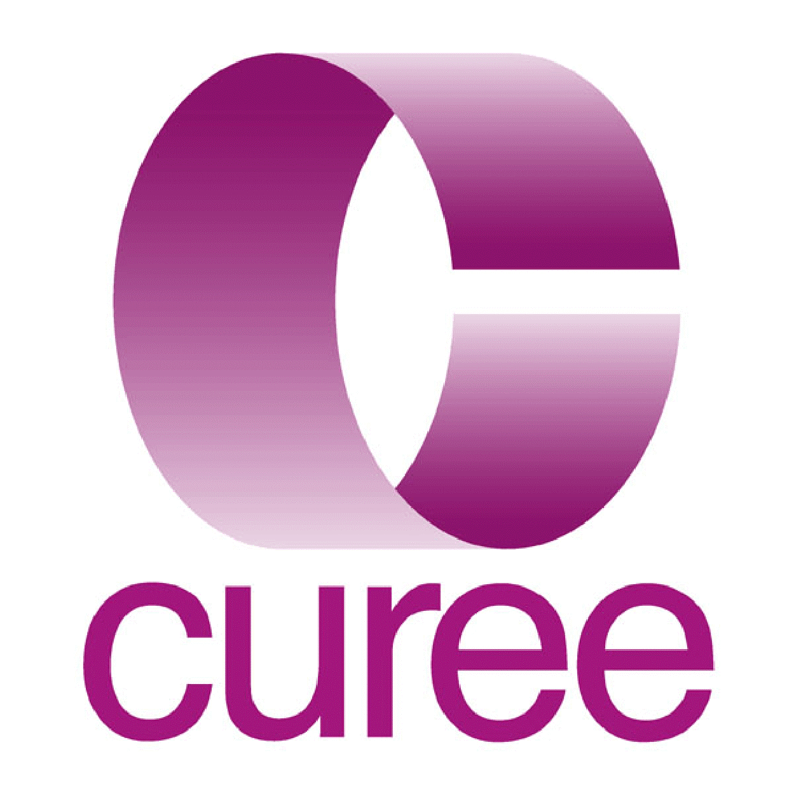

Centre for the Use of Research and Evidence in Education

4 Copthall House
Station Square
Coventry
CV1 2FL
cpd@curee.co.uk

