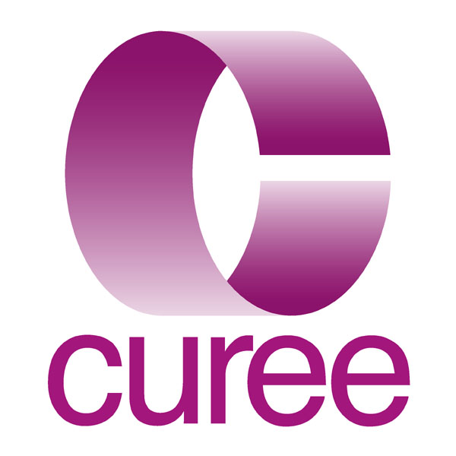
Knowledge Manager – Permanent post

The post

You’ll be working in a friendly, fast-paced, intellectually demanding environment where much of the work is groundbreaking. There will be opportunities to contribute in a variety of different ways to a wide range of different projects. There’s more information about the projects we are currently involved in below and on our website www.curee.co.uk. The post is based in Coventry, next to the train station. Some travel within the UK may be needed from time-to-time.

Core Responsibilities

- Co-ordinating and taking a central role in developing CUREE’s knowledge and information management strategy
- Extracting and managing data on relevant research from electronic databases and other published sources using search engines, query tools and other more traditional approaches;
- Providing a current awareness service;
- Designing, constructing and maintaining in-house databases of relevant material, including library catalogue;
- Supporting research managers in designing and implementing a range of appropriate research dissemination techniques including web sites and publication in more traditional forms (journals, articles, books etc);
- Designing and carrying out searches for systematic reviews;
- Recording review processes including searches;
- Producing technical reports and research briefings;
- Coding, entering and editing data in a variety of database formats;
- Contributing to the design of client databases;
- Maintaining a small collection of resources;
- Managing Intellectual Property Rights;
- Providing referencing services and advice;
- Website authoring/editing using content management systems.

Additional responsibilities (depending on qualifications and experience)

- Coordination of projects focused on knowledge management;
- Analysing research and writing summaries in an appropriate style and language for a practitioner audience;
- Preparing and delivering briefing and training sessions for other CUREE staff and, occasionally, clients’ personnel.

All staff are expected to work collaboratively as part of a team and to undertake other duties appropriate to their post’s grade and nature.

Terms and Conditions

This is a full-time post with normal hours of 37.5 per week, although flexible working would be considered for the right candidate. Holiday entitlement will be 20 days per year (rising to 25 after 5 years) in addition to Bank Holidays. Starting salary will fall within the range £18,000 to £28,000 depending upon experience, skills and knowledge of the appointed candidate. We would be willing to increase the salary to £30,000 for an exceptional candidate.

The company has a designated Stakeholder Pension Scheme, to which it makes a matching contribution of 4%.

How to apply

Please complete and return the attached application form. For further information please contact Kirsty Bond at CUREE on 024 7652 4036 or kirsty.bond@curee.co.uk

CUREE and its work

CUREE is an independent organisation at the leading edge of knowledge management. It is a leading research and policy influencing agency within education. Working with a range of individuals and organisation, mostly in the public sector, we provide writing, editing, research and training services to support the use of research and evidence to improve teaching and learning. We are proud of our ability to take the outcomes of academic research and explain how the findings can be used by teachers to improve what they do in the classroom. CUREE’s current major clients include the Qualifications and Curriculum Authority, the Department for Children, Schools and Families, the General Teaching Council for England, the Training and Development Agency and the Learning and Skills Improvement Service. Our work covers the full spectrum of education, from early years to Post 16.

CUREE has a small and collaborative core team based in Coventry and is also able to draw on a range of contributions from associates. We pride ourselves on our flexibility; of the staff and their response to new challenges, and of the organisation in accommodating family friendly working patterns. We are a flat organisation with little need for hierarchy. We are committed to the development of our staff. CUREE staff use their many skills for the benefit of our clients and are not particularly interested in the niceties of job demarcation.

We provide active support for continuing professional development, including the acquisition of relevant further academic and professional qualifications.

CUREE staff usually work on a number of projects, and with a range of clients, at any one time. For examples of our current projects look on our website: www.curee.co.uk. We currently use a range of data management and other IT tools including Access, Drupal and Knowledge Tree.

Knowledge Manager Person Specification

 | Essential | Desirable
Qualifications | - First degree (or similar), preferably in a numerate discipline | - Post-graduate qualification in information science or librarianship
Knowledge of | (At least 3 of the following 4 areas in this category essential)  - online discovery and retrieval systems (including concepts such as meta-tagging and standards);  - general understanding of the principles of data analysis and relational databases in particular;  - database management and interrogation systems such as Access;  - online data repositories;  - content management systems. | - general principles of web publishing and specific familiarity with web authoring tools like FrontPage, Dreamweaver and ColdFusion;  - the general organisation of the UK education system;  - education specific databases and resources (journals, CPD resources etc).
Experience of | - administration and self-organisation  - undertaking research or enquiry  - experience of working in an office environment | - project management;  - writing for a variety of audiences;  - working (paid or unpaid) in an educational environment
IT Skills | - word-processing, email and file management;  - spreadsheets;  - database management;  - sourcing information using the web and/or web-based databases. | - web development tools;  - PowerPoint.
Skills & attributes | - ability to analyse problems or information systematically and in depth;  - ability to take initiative and responsibility for your work;  - an openness to new experiences, an enquiring approach to what you know already and a eagerness to learn more;  - excellent written and oral communication skills;  - organisational skills – of yourself and of others;  - ability to understand/put yourself in the shoes of customers, readers, learners and colleagues;  - ability to contribute effectively as part of a team;  - flexibility and multi-tasking;  - optimism, cheerfulness and an interest in other people. | - ability to make connections between ideas and projects, between theory and practice;  - ability to function with strategic rather than day-to-day supervision;  - capacity for honest reflective self appraisal;  - persuasive interpersonal skills.

