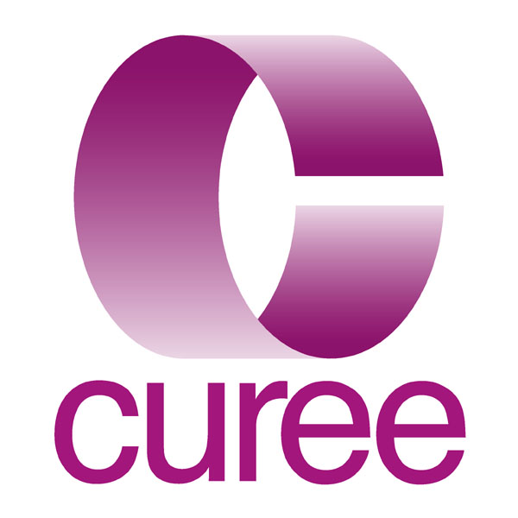
Knowledge and Information Manager – Permanent post

Summary

In the next few paragraphs you will find a description of CUREE, what it does, what you would do if you joined us, and something about the people here. We think CUREE is unique - well, we would, wouldn’t we? – but we are certainly unusual in the way we bring together a range of activities, and skills, which are not often found together. Most people enjoy working for us but it takes them a while to get to understand what we do. Please take the time to look through this information, and look us up on our website, to get a good picture of what we do so you can decide if you would like to do it too.

You’ll be working in a friendly, fast-paced, intellectually demanding environment where much of the work is groundbreaking. There will be opportunities to contribute in a variety of different ways to a wide range of different projects. There’s more information about the projects we are currently involved in below and on our website www.curee.co.uk. The post is based in Coventry, next to the train station. Some travel within the UK may be needed from time-to-time.

CUREE and its work

CUREE is an independent organisation at the leading edge of knowledge management. It is a leading research and policy influencing agency within education. Working with a range of individuals and organisations, mostly in the public sector, we provide writing, editing, research and training services to support the use of research and evidence to improve teaching and learning. We are proud of our ability to take the outcomes of academic research and explain how the findings can be used by teachers to improve what they do in the classroom. CUREE’s current major clients include the Qualifications and Curriculum Authority, the Department for Children, Schools and Families, the General Teaching Council for England, the Training and Development Agency and the Learning and Skills Improvement Service. Our work covers the full spectrum of education, from early years to Post 16.

The people

CUREE has a small core team based in Coventry extended and enhanced by associates some of whom are long standing contributors integrated into the team. At any one time CUREE is about 24 strong. Associates are home-based in the main. As a small group we need little formal internal structures or hierarchy. For operational purposes the staff are loosely grouped into two teams; the ‘content’ team and the ‘infrastructure’ team. CUREE will generally be working on around a dozen projects at any one time and an ad hoc project team will be put together to work on that project. Projects usually have a director and a co-ordinator. The co-ordinator will usually be drawn from the content team each of whom will co-ordinate at least one project. So team members will typically be working in two or three project teams at any one time.

Most staff are graduates and have a professional background from teaching, research, policy, information science, journalism and marketing. We pride ourselves on our flexibility; of the staff and their response to new challenges, and of the organisation in accommodating family friendly working patterns. People might join us with very specific skills or experience but we expect them to become multi-skilled and we are committed to helping them become so. No-one says ‘I can’t do that’ but someone might reasonably say ‘I can’t do that yet’
The Job

CUREE’s business is the manipulation of information – gathering, sifting, processing and refining it so that it is useful to our clients. We collect information and we make knowledge which we share with others. Everybody’s job in CUREE involves some knowledge management but one job has the management of knowledge as its primary purpose – and this is that job. It has elements of research librarian about it (though most of the ‘stock’ is digital) and a lot of data management. We currently use a range of data management and other IT tools including Access, Drupal, Knowledge Tree, SPSS and Nvivo. The list below gives a bit more detail about the range of responsibilities:

The job in a little more detail:

- co-ordinating and taking a central role in developing CUREE’s knowledge and information management strategy
- designing and refining search and retrieval processes to harvest relevant research from a wide range of online (and hard-copy) sources;
- extracting and managing data on relevant research from electronic databases and other published sources using search engines, query tools and other more traditional approaches;
- coordinating a current awareness service;
- designing, constructing and maintaining in-house databases of relevant material, including library catalogue;
- designing, or helping others to design, research data retrieval, storage, and analysis techniques and tools to support primary and secondary research activities
- providing a referencing service and advice to other team members and occasionally to clients;
- designing and carrying out searches for systematic reviews;
- producing technical reports and research briefings;
- coding, entering and editing data in a variety of database formats;
- contributing to the design of client databases;
- maintaining a collection of physical (books, articles etc) and digital resources; and
- advising on the management of Intellectual Property Rights.

Additional responsibilities (depending on qualifications and experience)

- preparing and delivering briefing and training sessions for other CUREE staff and occasionally clients’ personnel;
- coordination of projects focused on knowledge management;
- analysing research and writing summaries in an appropriate style and language for a practitioner audience; and
- participating in the overall management and co-ordination of CUREE’s ICT infrastructure.

All staff are expected to work collaboratively as part of a team and to undertake other duties appropriate to their post’s grade and nature.

Terms and Conditions

This is a full-time post with normal hours of 37.5 per week, although flexible working would be considered for the right candidate. Holiday entitlement will be 20 days per year (rising to 25 after 5 years) in addition to Bank Holidays. Starting salary will fall within the range £18,000 to £28,000 depending upon experience, skills and knowledge of the appointed candidate. We would be willing to increase the salary to £30,000 for an exceptional candidate.

The company has a designated Stakeholder Pension Scheme, to which it makes a matching contribution of 4%.

We provide active support for continuing professional development, including the acquisition of relevant further academic and professional qualifications.

How to apply

Please complete and return the attached application form. For further information please contact Sophie Kennedy at CUREE on 024 7652 4036 or sophie.kennedy@curee.co.uk

Knowledge and Information Manager Person Specification

 | Essential | Desirable
Qualifications | - first degree (or similar), preferably in a quantitative discipline | - Post-graduate qualification in information science or librarianship
Knowledge of | (At least 3 of the following 4 areas in this category essential)  - online discovery and retrieval systems  - general principles and specific applications of the organisation of information (including concepts such as taxonomies, dictionaries and glossaries, meta-tagging and standards)  - general understanding of the principles of data analysis and relational databases in particular  - database management and interrogation systems such as Access  - online data repositories  - content management systems | - education specific databases and resources (journals, CPD resources etc)  - the application of Web 2.0 technologies to information management (e.g. wikis, folksonomies)
Experience of | - administration and self-organisation  - undertaking research or enquiry  - experience of working in an office environment | - project management  - writing for a variety of audiences  - working (paid or unpaid) in an educational environment
IT Skills | - word-processing, email and file management  - spreadsheets  - database management  - sourcing information using the web and/or web-based databases | - PowerPoint  - SPSS  - Nvivo  - Knowledge Tree  - SPSS
Skills & attributes | - ability to analyse problems or information systematically and in depth  - ability to take initiative and responsibility for your work  - an openness to new experiences, an enquiring approach to what you know already and a eagerness to learn more  - excellent written and oral communication skills  - organisational skills – of yourself and of others  - ability to understand/put yourself in the shoes of customers, readers, learners and colleagues  - ability to contribute effectively as part of a team  - flexibility and multi-tasking  - optimism, cheerfulness and an interest in other people | - ability to make connections between ideas and projects, between theory and practice  - ability to function with strategic rather than day-to-day supervision  - capacity for honest reflective self appraisal  - persuasive interpersonal skills

